MODULE END EXAM

PG -DBDA

ROLL NO.- 240840325063

# Cloud

Q1 you are rquired to design a secure and functional cloud infracture using AWS servies.

Create a new IAM user with programmatic access, ensuring that user has a policy granting EC2 Full access.

Answer-

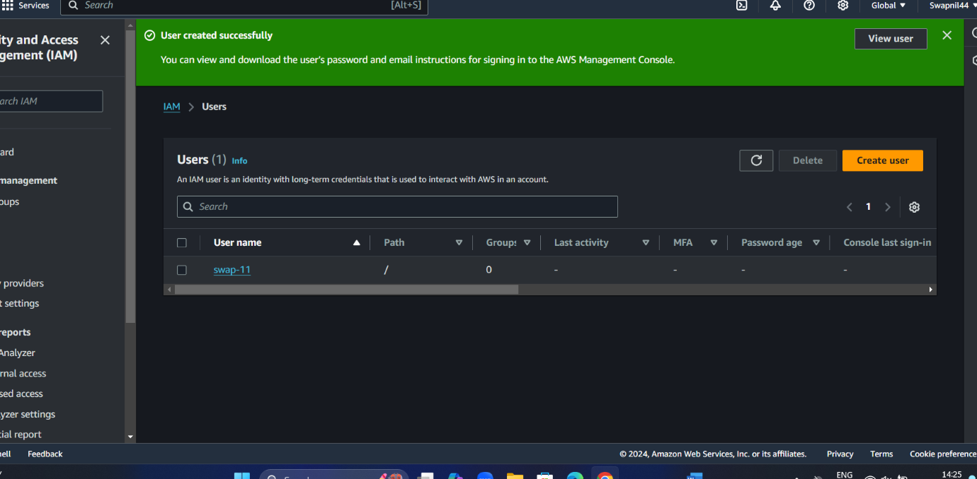

There is we create user in IAM



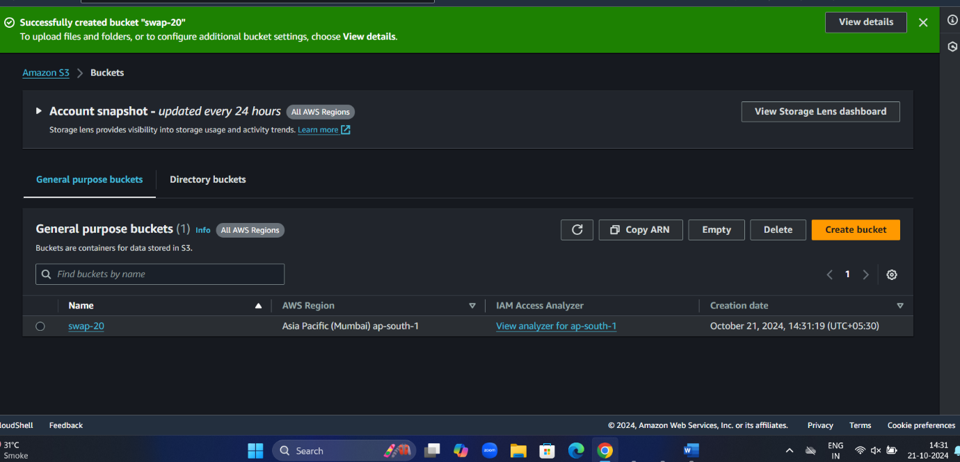

Create bucket in s3 with swap-20 name

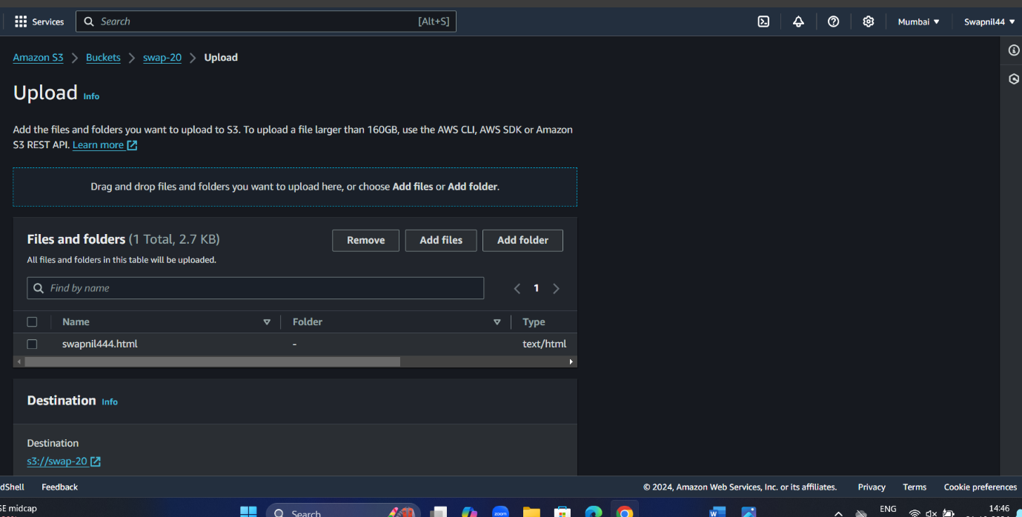

Here is uploaded the file in html format with containing massage “hello ,welcome to my page”

#linux

1.create a new directory

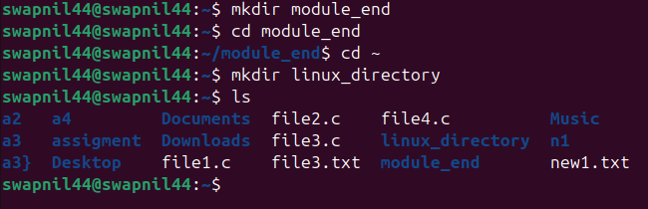

Code – make directory

mkdir linux_directory

code to rename- mv linux_directory new_dir

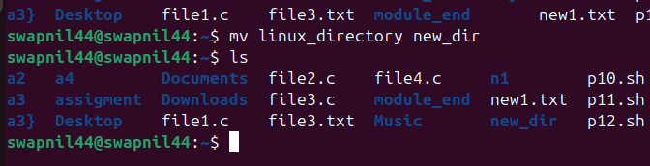

Move- there we used mv command

Mv a4 /home/swapnil44/h1 here we give the path to move file one to other place

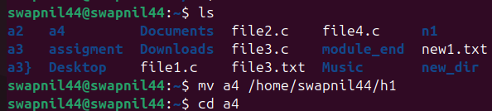

For permission

Chmod u+x new1.txt

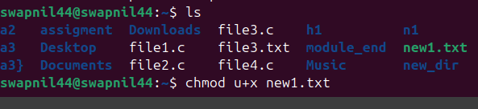

For delete the –

Code rm file3.c

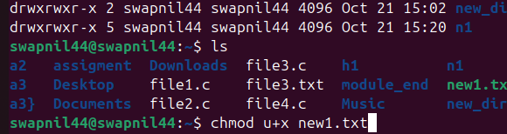

**IAM

Create user – admin(admin),read-only, s3 accesss (full access) > ceate user >next>attacted policies>admin related to admin access (same to all)

Roles>crate role>select ec2 >next>s3fullacdess>next>role name>s3-fullaccess>crate role (admin)

Go>user>securtity credientials > assign MFA device>give name>select mobile>get virtul link (no select)

“attach exit EC@ instance”>EC2>select instance>action>security>mode of IAM role>ec2-s3-fullaccess

<!DOCTYPE html>

<html lang="en">

<head>

<meta charset="UTF-8">

<meta name="viewport" content="width=device-width, initial-scale=1.0">

<title>Welcome to My Page</title>

<style>

body {

font-family: Arial, sans-serif;

background-color: #f0f0f0;

margin: 0;

padding: 20px;

}

header {

text-align: center;

padding: 50px;

background-color: #4CAF50;

color: white;

}

footer {

text-align: center;

padding: 20px;

background-color: #333;

color: white;

position: fixed;

bottom: 0;

width: 100%;

}

main {

margin: 20px;

text-align: center;

}

</style>

</head>

<body>

<header>

<h1>Welcome to My Page!</h1>

</header>

<main>

<p>Thank you for visiting. Enjoy your stay!</p>

</main>

<footer>

<p>&copy; 2024 My Page</p>

</footer>

</body>

</html>